Report for ForestQuery into Global Deforestation, 1990 to 2016

ForestQuery is on a mission to combat deforestation around the world and to raise awareness about this topic and its impact on the environment. The data analysis team at ForestQuery has obtained data from the World Bank that includes forest area and total land area by country and year from 1990 to 2016, as well as a table of countries and the regions to which they belong.

The data analysis team has used SQL to bring these tables together and to query them in an effort to find areas of concern as well as areas that present an opportunity to learn from successes.

## 1. **GLOBAL SITUATION**

According to the World Bank, the total forest area of the world was 41282694.9 km2 in 1990. As of 2016, the most recent year for which data was available, that number had fallen to39958245.9 km2, a loss of 1324449 km2, or 3.21%.

The forest area lost over this time period is slightly more than the entire land area of Mongolia listed for the year 2016 (which is 1553560 km2).

## 2. **REGIONAL OUTLOOK**

In 2016, the percent of the total land area of the world designated as forest was 31.38%. The region with the highest relative forestation was Latin America & Caribbean with 46.16% and the region with the lowest relative forestation was Middle East & North Africa with 2.07% forestation.

In 1990, the percent of the total land area of the world designated as forest was 32.42% The region with the highest relative forestation was Latin America & Caribbean, with 51.03%, and the region with the lowest relative forestation was Middle East & North Africa, with 1.78% forestation.

Table 2.1: Percent Forest Area by Region, 1990 & 2016:

|  |  |  |
| --- | --- | --- |
| Region | 1990 Forest Percentage | 2016 Forest Percentage |
| East Asia & Pacific | 25.78 | 26.36 |
| Europe & Central Asia | 37.28 | 38.04 |
| Latin America & Caribbean | 51.03 | 46.16 |
| Middle East & North Africa | 1.78 | 2.07 |
| North America | 35.65 | 36.04 |
| South Asia | 16.51 | 17.51 |
| Sub-Saharan Africa | 30.67 | 28.79 |

The only regions of the world that decreased in percent forest area from 1990 to 2016 were Sub-Saharan Africa (dropped from 30.67% to 28.79%) and Latin America & Caribbean (51.03% to 46.16%). All other regions actually increased in forest area over this time period. However, the drop in forest area in the two aforementioned regions was so large, the percent forest area of the world decreased over this time period from 32.42% to 31.38%.

## 3. **COUNTRY-LEVEL DETAIL**

### SUCCESS STORIES

There is one particularly bright spot in the data at the country level, China. This country actually increased in forest area from 1990 to 2016 by 527229.06 km2. It would be interesting to study what has changed in this country over this time to drive this figure in the data higher. The country with the next largest increase in forest area from 1990 to 2016 was the United States, but it only saw an increase of 79200 km2, much lower than the figure for China.

China and United States are of course very large countries in total land area, so when we look at the largest *percent* change in forest area from 1990 to 2016, we aren’t surprised to find a much smaller country listed at the top. Iceland increased in forest area by 313.66% from 1990 to 2016.

### LARGEST CONCERNS

Which countries are seeing deforestation to the largest degree? We can answer this question in two ways. First, we can look at the absolute square kilometer decrease in forest area from 1990 to 2016. The following 5 countries had the largest decrease in forest area over the time period under consideration:

Table 3.1: Top 5 Amount Decrease in Forest Area by Country, 1990 & 2016:

|  |  |  |
| --- | --- | --- |
| Country | Region | Absolute Forest Area Change [km2] |
| Brazil | Latin America & Caribbean | -541510 |
| Indonesia | East Asia & Pacific | -282194 |
| Myanmar | East Asia & Pacific | -107234 |
| Nigeria | Sub-Saharan Africa | -106506 |
| Tanzania | Sub-Saharan Africa | -102320 |

The second way to consider which countries are of concern is to analyze the data by percent decrease.

Table 3.2: Top 5 Percent Decrease in Forest Area by Country, 1990 & 2016:

|  |  |  |
| --- | --- | --- |
| Country | Region | Pct Forest Area Change |
| Togo | Sub-Saharan Africa | -75.45 |
| Nigeria | Sub-Saharan Africa | -61.8 |
| Uganda | Sub-Saharan Africa | -59.13 |
| Mauritania | Sub-Saharan Africa | -46.75 |
| Honduras | Latin America & Caribbean | -45.03 |

When we consider countries that decreased in forest area the most between 1990 and 2016, we find that four of the top 5 countries on the list are in the region of Sub-Saharan Africa. The countries are Togo, Nigeria, Uganda, and Mauritania. The 5th country on the list is Honduras, which is in the Latin America & Caribbean region.

From the above analysis, we see that Nigeria is the only country that ranks in the top 5 both in terms of absolute square kilometer decrease in forest as well as percent decrease in forest area from 1990 to 2016. Therefore, this country has a significant opportunity ahead to stop the decline and hopefully spearhead remedial efforts.

### QUARTILES

Table 3.3: Count of Countries Grouped by Forestation Percent Quartiles, 2016:

|  |  |
| --- | --- |
| Quartile | Number of Countries |
| First | 85 |
| Second | 73 |
| Third | 38 |
| Fourth | 9 |

The largest number of countries in 2016 were found in the first quartile.

There were 9 countries in the top quartile in 2016. These are countries with a very high percentage of their land area designated as forest. The following is a list of countries and their respective forest land, denoted as a percentage.

Table 3.4: Top Quartile Countries, 2016:

|  |  |  |
| --- | --- | --- |
| Country | Region | Pct Designated as Forest |
| Suriname | Latin America & Caribbean | 98.26 |
| Micronesia, Fed. Sts. | East Asia & Pacific | 91.86 |
| Gabon | Sub-Saharan Africa | 90.04 |
| Seychelles | Sub-Saharan Africa | 88.41 |
| Palau | East Asia & Pacific | 87.61 |
| American Samoa | East Asia & Pacific | 87.50 |
| Guyana | Latin America & Caribbean | 83.90 |
| Lao PDR | East Asia & Pacific | 82.11 |
| Solomon Islands | East Asia & Pacific | 77.86 |

## 4. RECOMMENDATIONS

*Write out a set of recommendations as an analyst on the ForestQuery team.*

* *What have you learned from the World Bank data?*
* *Which countries should we focus on over others?*

Based on analysis from the World Bank, there are signs of further shrinkage of global forest area. Most attention should be focused on countries where there has been the greatest percentage reduction in forest area. Those countries are Togo, Nigeria, Uganda, Mauritania and Honduras. Four out of five those countries are located in the Sub-Saharan Africa region and all have low to lower middle income. It is important to assess the reasons for the decline in forest cover in these regions. Whether this is due to sourcing of exotic wood, agriculture, fires or climate changes. A good example of a country that has increased its forest area is China. This case should be studied and recommendations made for low income countries.

## 5. APPENDIX: SQL queries used

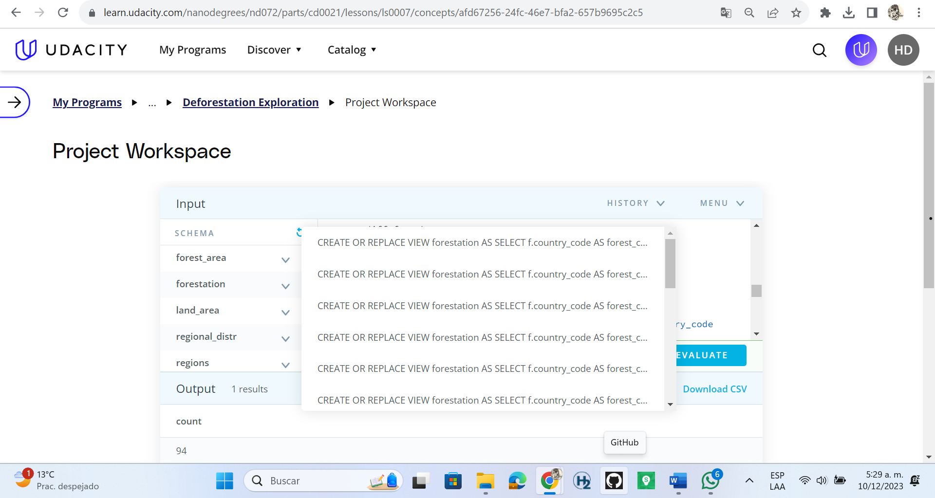

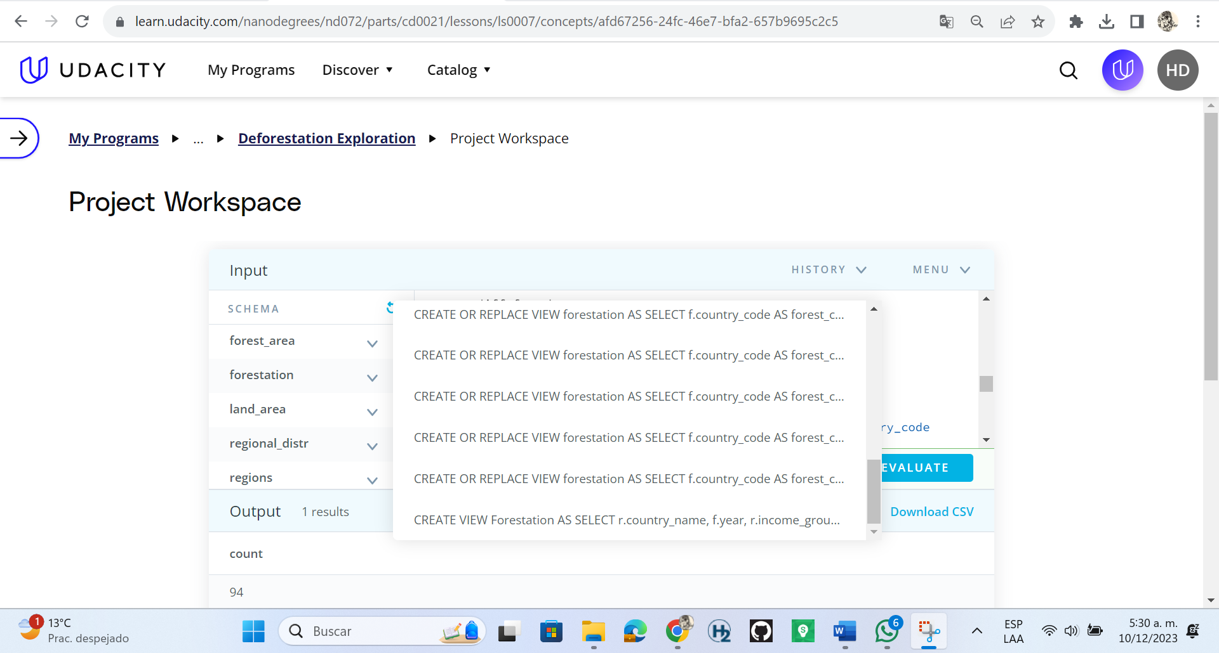

## Create View

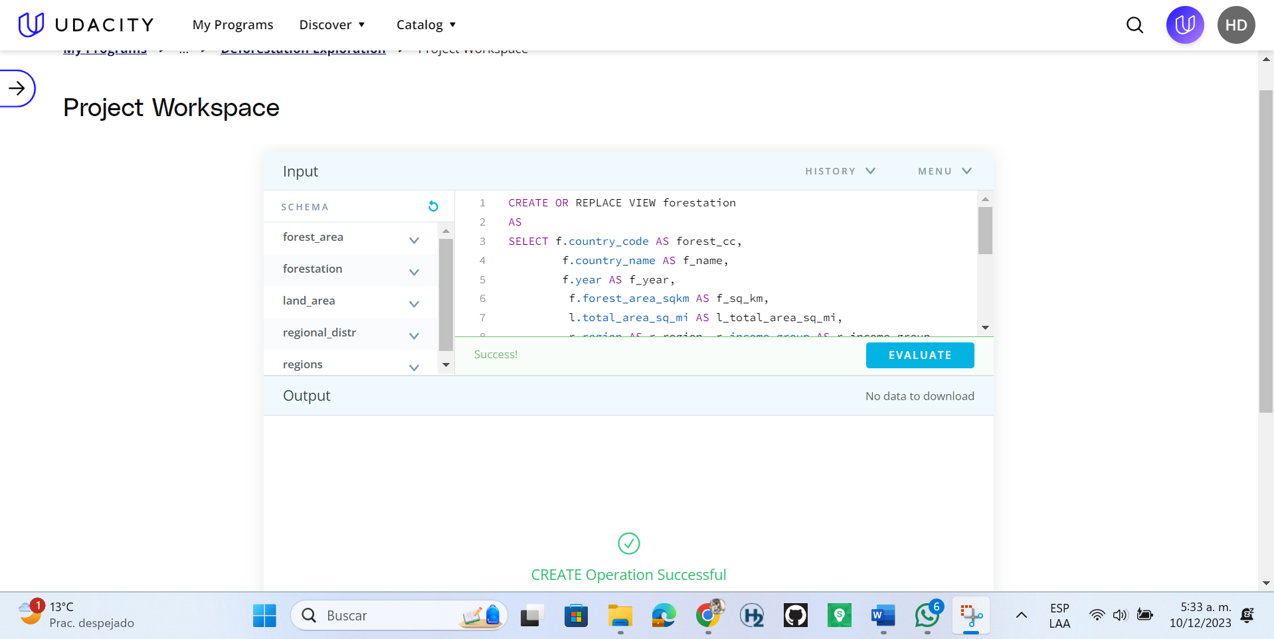

a. What was the total forest area (in sq km) of the world in 1990? Please keep in mind that you can use the country record denoted as “World" in the region table.

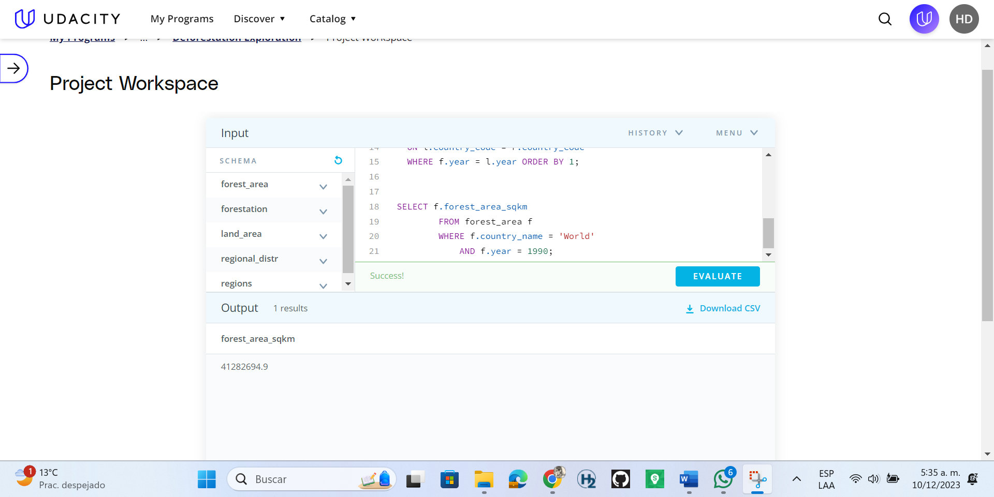

What was the total forest area (in sq km) of the world in 2016? Please keep in mind that you can use the country record in the table is denoted as "World"?

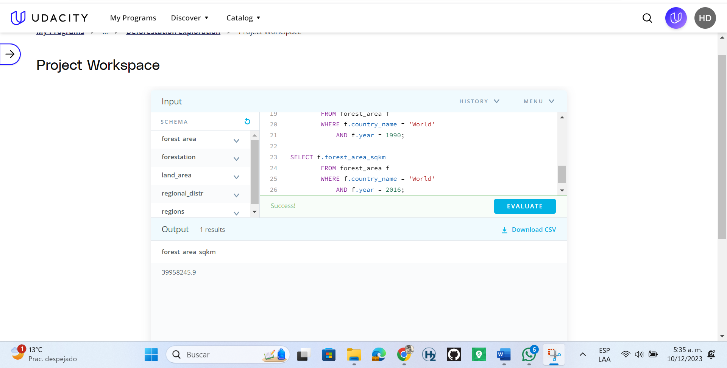

What was the change (in sq km) in the forest area of the world from 1990 to 2016?

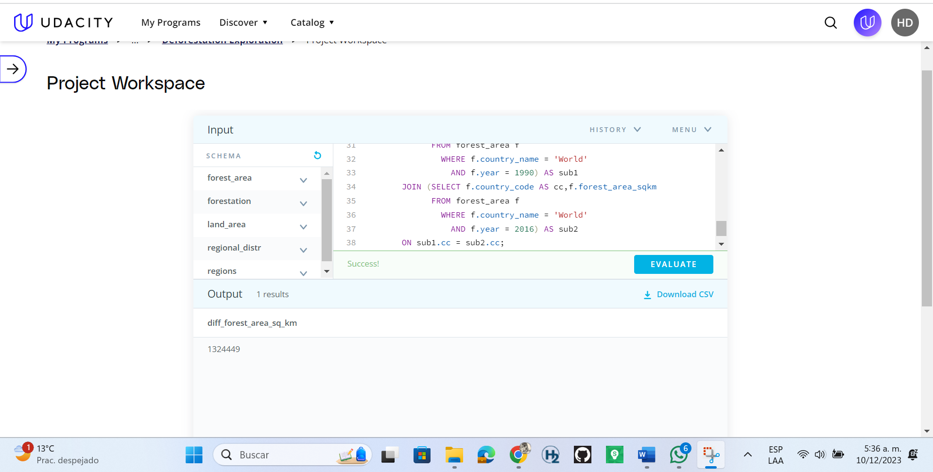

If you compare the amount of forest area lost between 1990 and 2016, to which country's total area in 2016 is it closest to?

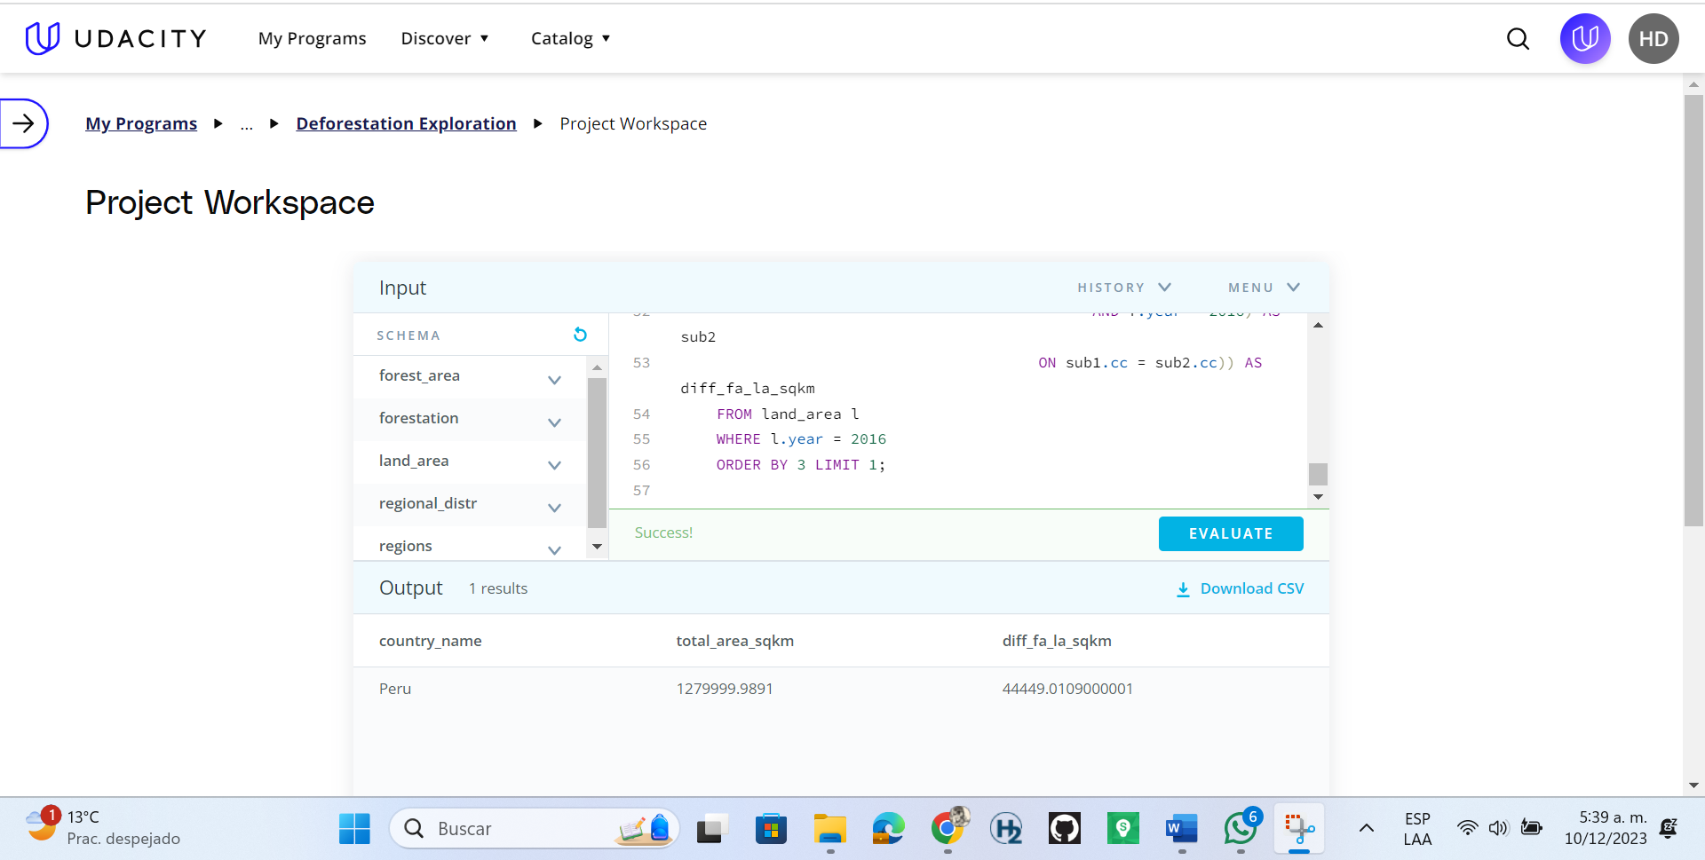

Create a table that shows the Regions and their percent forest area (sum of forest area divided by sum of land area) in 1990 and 2016. (Note that 1 sq mi = 2.59 sq km)

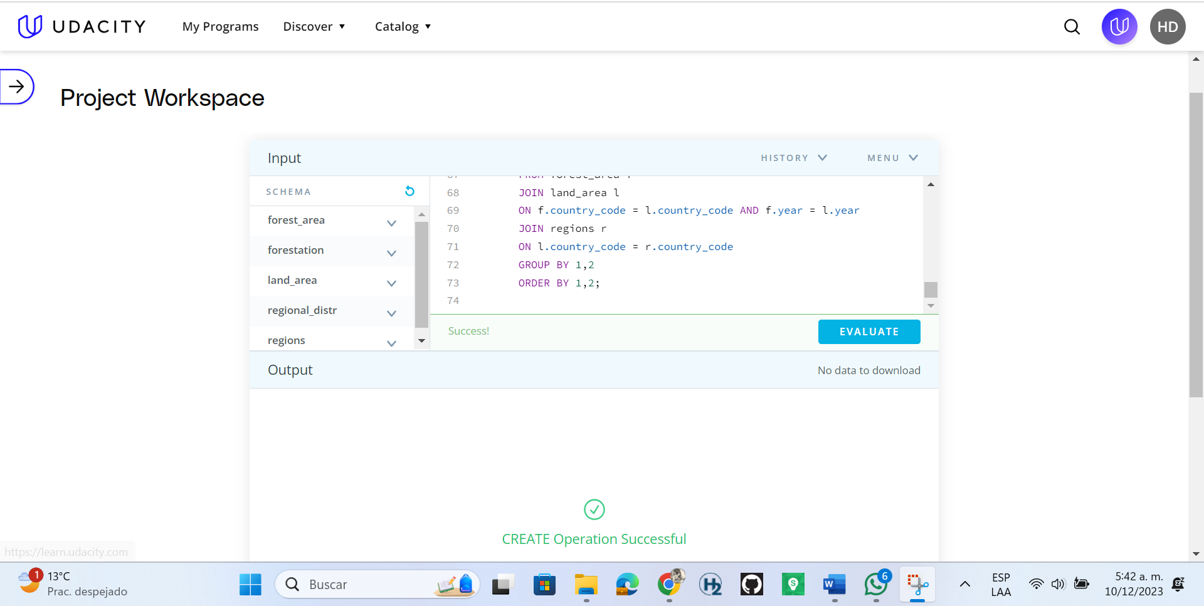

What was the percent forest of the entire world in 2016?

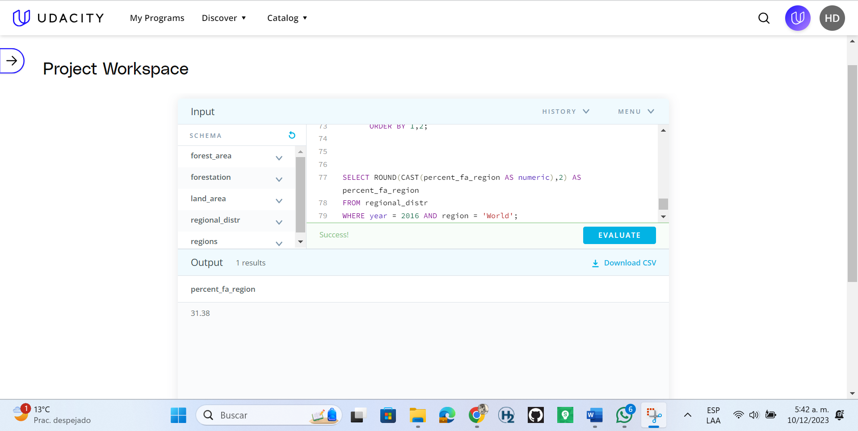

Which region had the HIGHEST percent forest in 2016, and which had the LOWEST, to 2 decimal places?

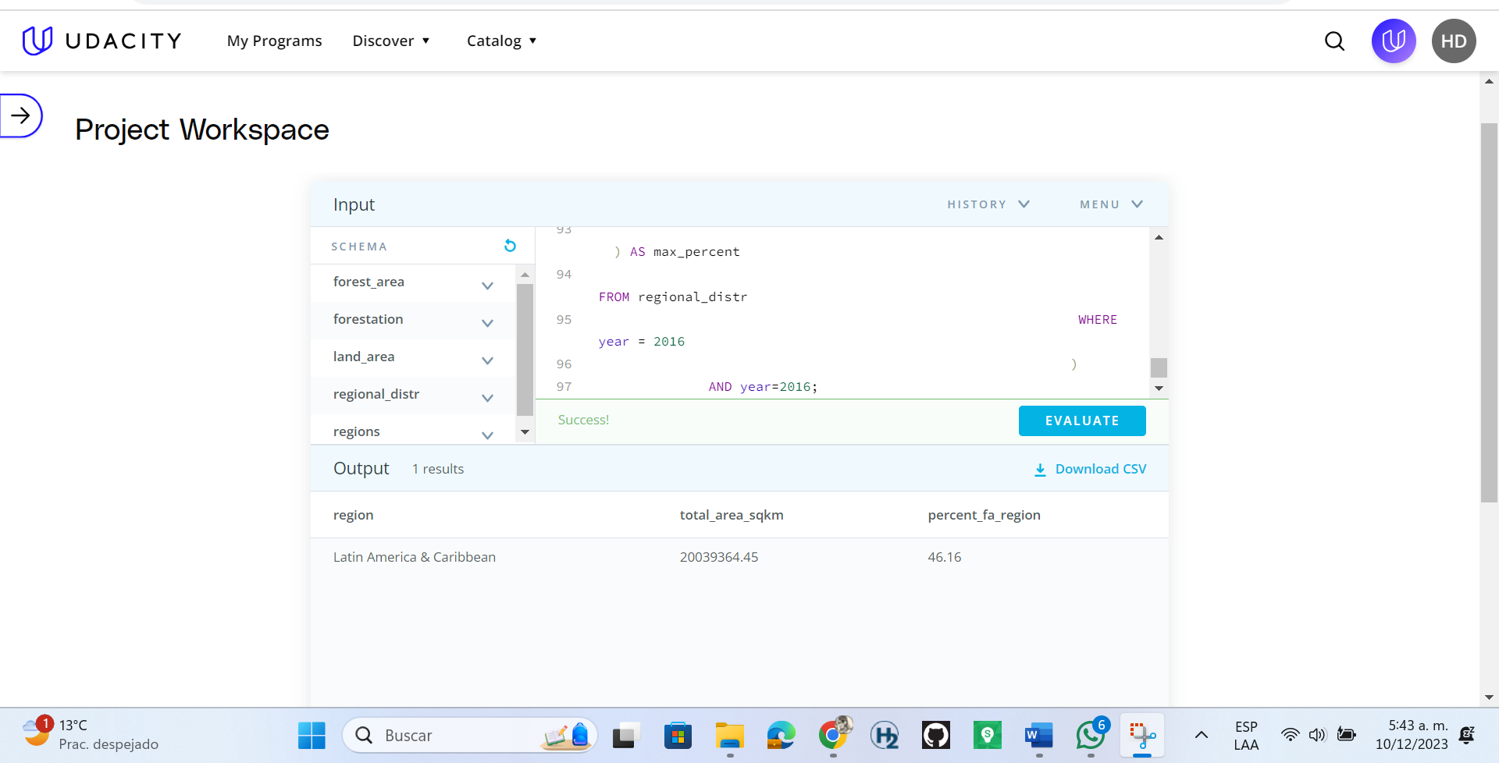

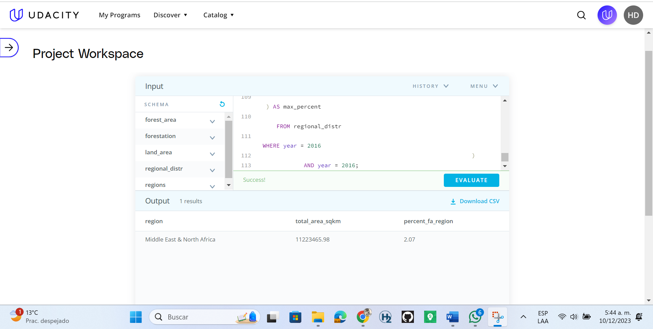

What was the percent forest of the entire world in 1990?

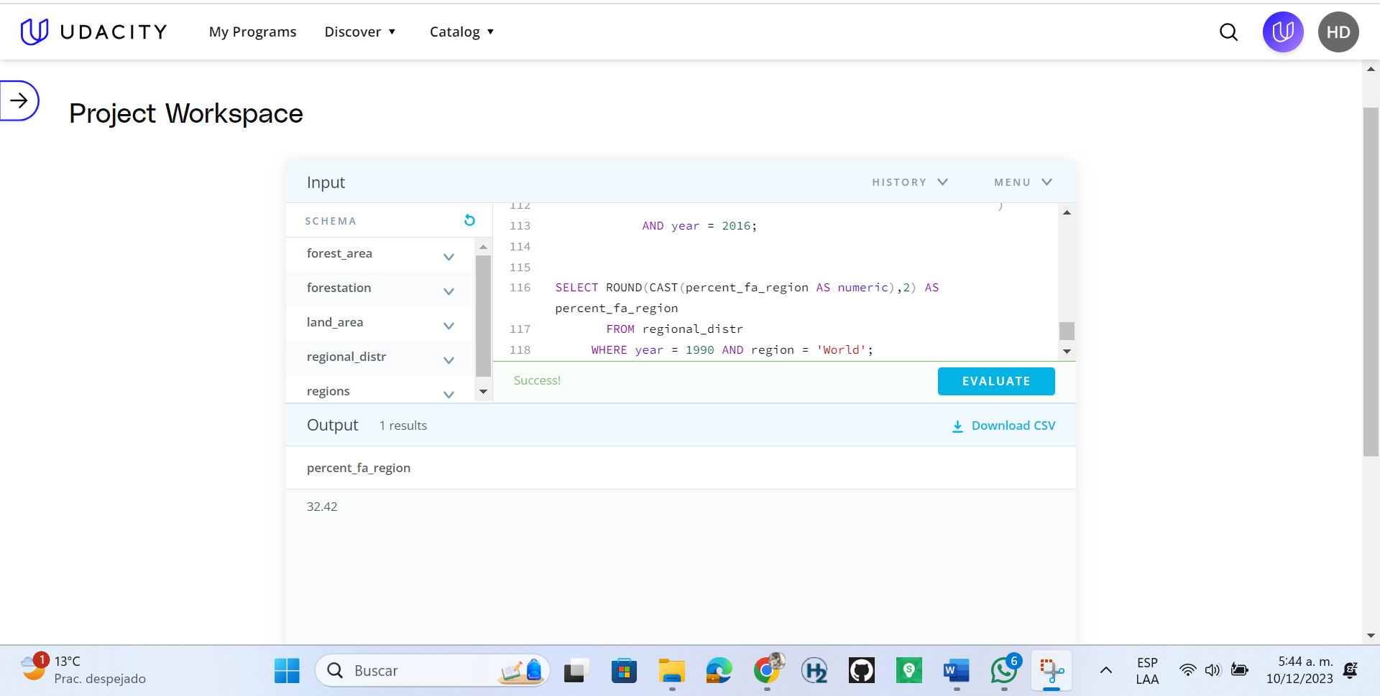

Which region had the HIGHEST percent forest in 1990, and which had the LOWEST, to 2 decimal places?

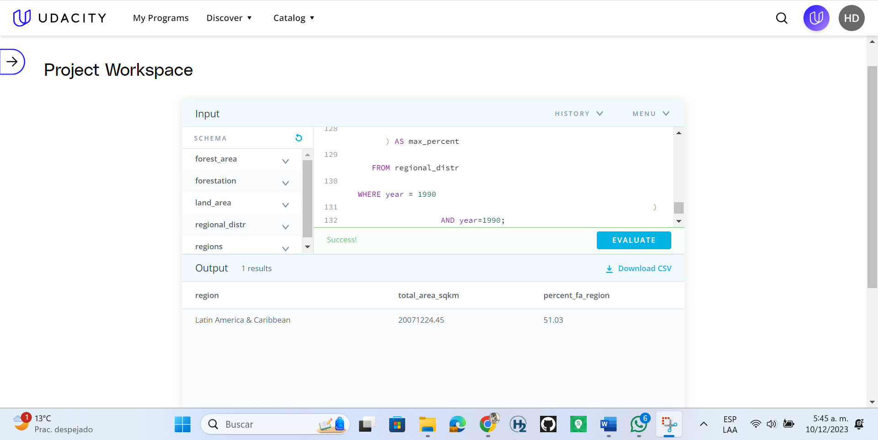

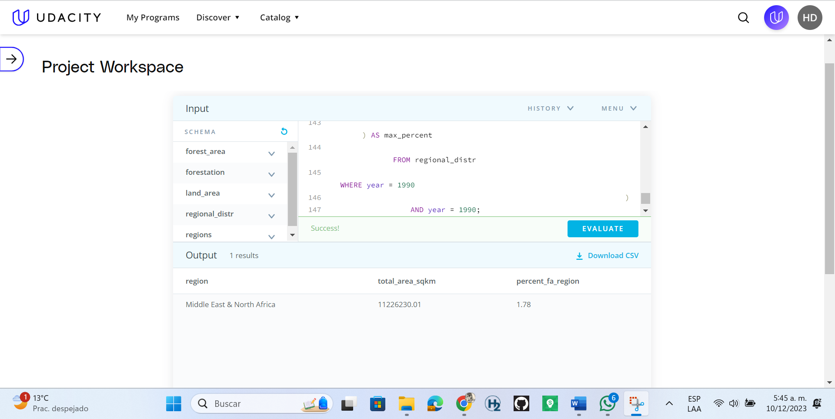

Based on the table you created, which regions of the world DECREASED in forest area from 1990 to 2016?

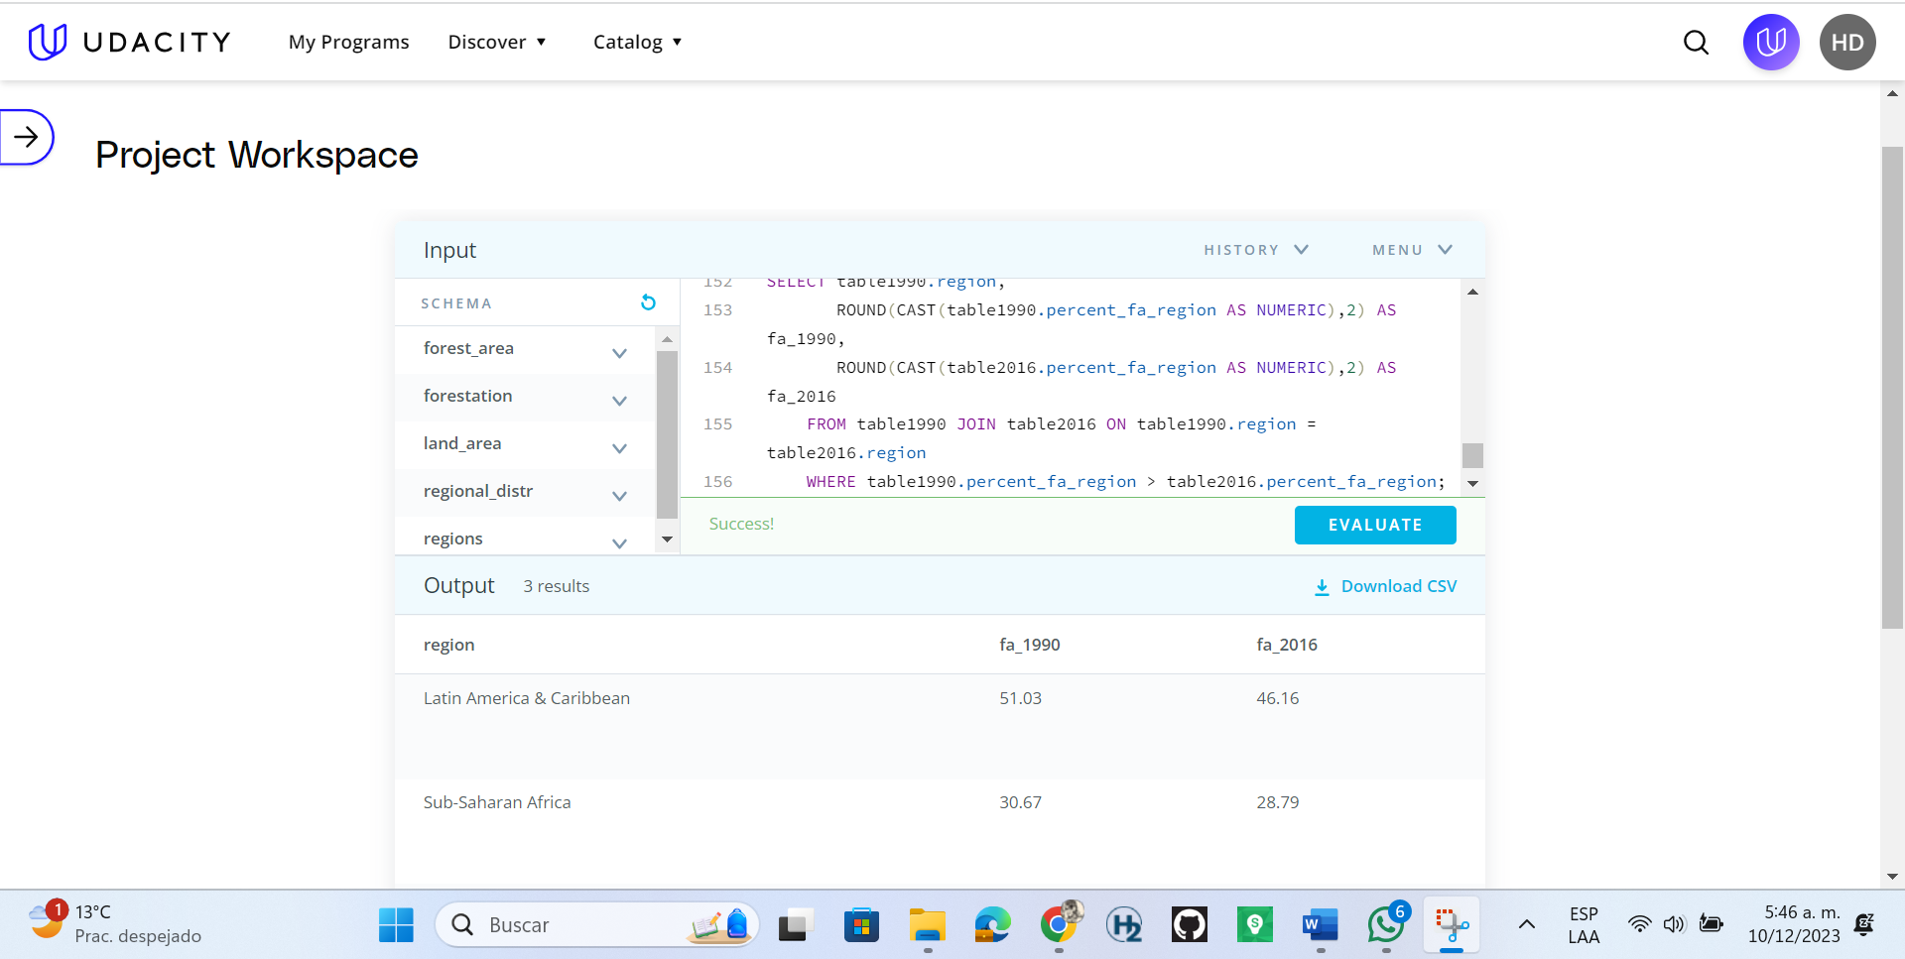

Which 5 countries saw the largest amount decrease in forest area from 1990 to 2016? What was the difference in forest area for each?

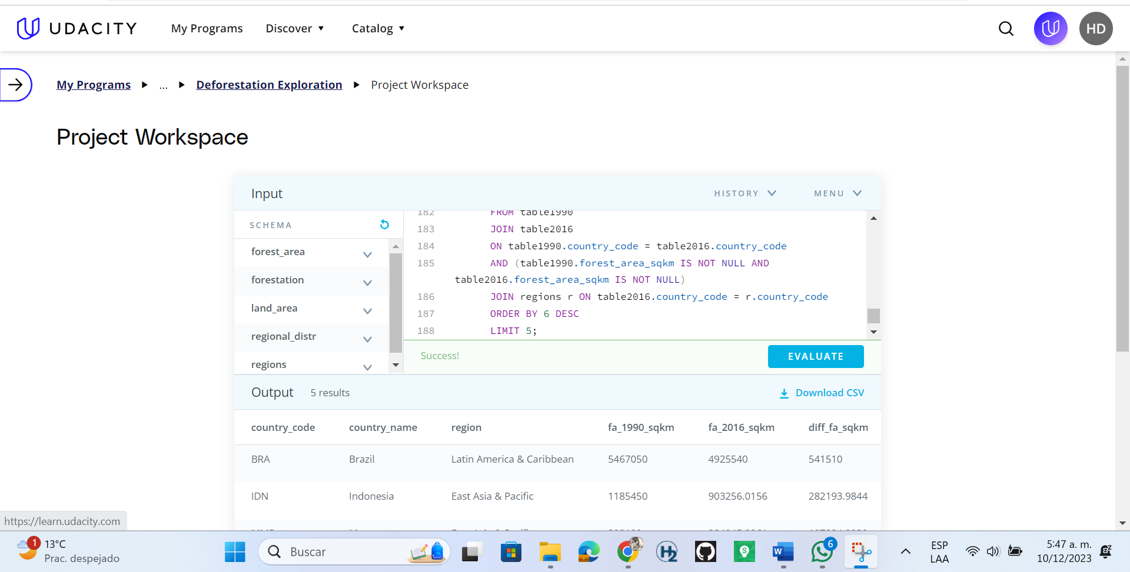

Which 5 countries saw the largest percent decrease in forest area from 1990 to 2016? What was the percent change to 2 decimal places for each

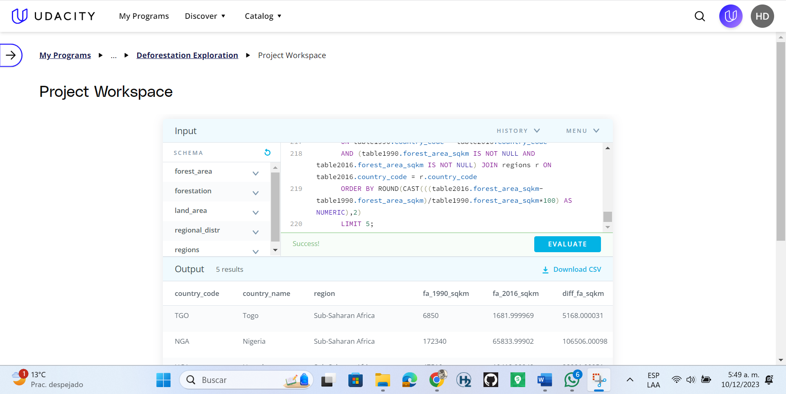

If countries were grouped by percent forestation in quartiles, which group had the most countries in it in 2016?

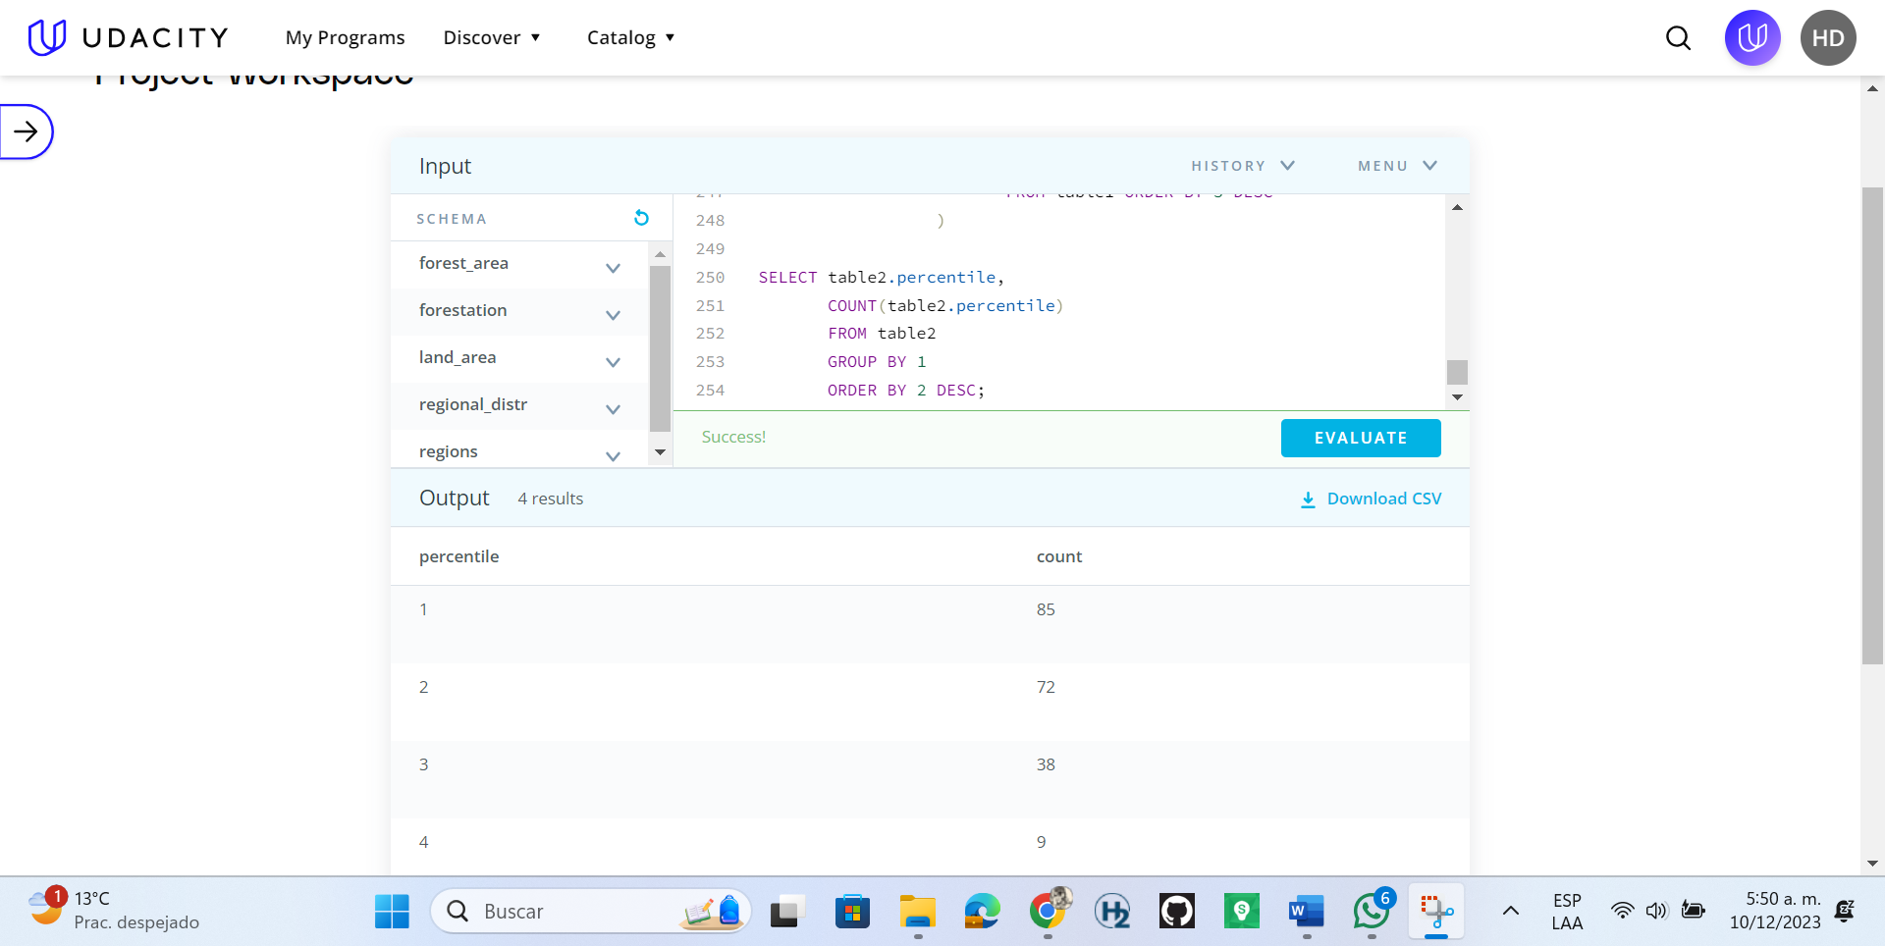

List all of the countries that were in the 4th quartile (percent forest > 75%) in 2016.

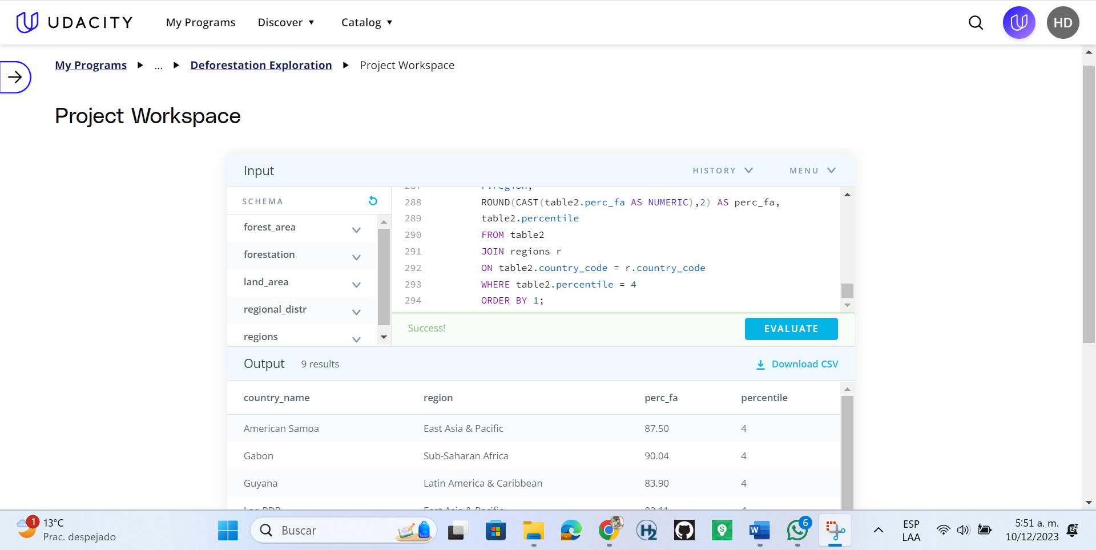

How many countries had a percent forestation higher than the United States in 2016?

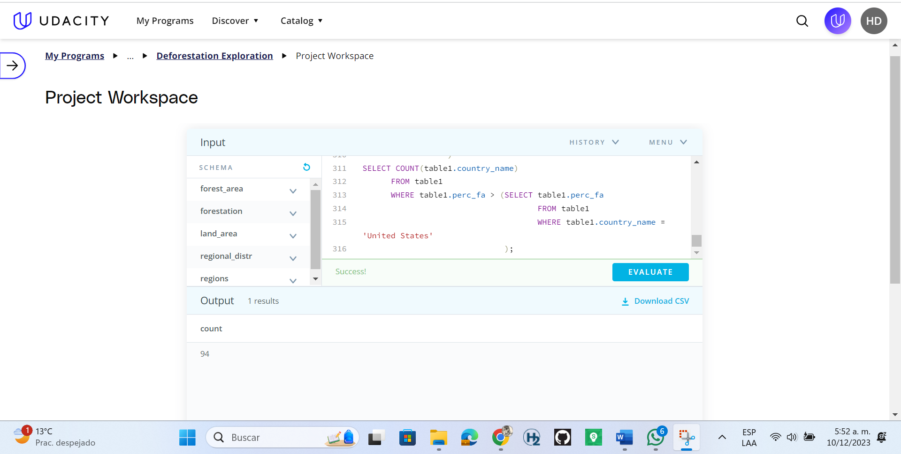

CREATE OR REPLACE VIEW forestation

AS

SELECT f.country_code AS forest_cc,

f.country_name AS f_name,

f.year AS f_year,

f.forest_area_sqkm AS f_sq_km,

l.total_area_sq_mi AS l_total_area_sq_mi,

r.region AS r_region, r.income_group AS r_income_group,

(f.forest_area_sqkm/(l.total_area_sq_mi*2.59))*100 AS perc_forest_area

FROM forest_area f

Join land_area l

ON f.country_code = l.country_code

JOIN regions r

ON l.country_code = r.country_code

WHERE f.year = l.year ORDER BY 1;

SELECT f.forest_area_sqkm

FROM forest_area f

WHERE f.country_name = 'World'

AND f.year = 1990;

SELECT f.forest_area_sqkm

FROM forest_area f

WHERE f.country_name = 'World'

AND f.year = 2016;

SELECT sub1.forest_area_sqkm - sub2.forest_area_sqkm AS diff_forest_area_sq_km

FROM (SELECT f.country_code AS cc, f.forest_area_sqkm

FROM forest_area f

WHERE f.country_name = 'World'

AND f.year = 1990) AS sub1

JOIN (SELECT f.country_code AS cc,f.forest_area_sqkm

FROM forest_area f

WHERE f.country_name = 'World'

AND f.year = 2016) AS sub2

ON sub1.cc = sub2.cc;

SELECT ((sub1.forest_area_sqkm-sub2.forest_area_sqkm)/sub1.forest_area_sqkm)*100 AS perc_change_fa

FROM (SELECT f.country_code AS cc, f.forest_area_sqkm

FROM forest_area f

WHERE f.country_name = 'World'

AND f.year = 1990) AS sub1

JOIN (SELECT f.country_code AS cc,f.forest_area_sqkm

FROM forest_area f

WHERE f.country_name = 'World'

AND f.year = 2016) AS sub2

ON sub1.cc = sub2.cc;

SELECT l.country_name,

l.total_area_sq_mi*2.59 AS total_area_sqkm,

ABS((l.total_area_sq_mi*2.59)- (SELECT sub1.forest_area_sqkm - sub2.forest_area_sqkm AS diff_forest_area_sq_km

FROM (SELECT f.country_code AS cc, f.forest_area_sqkm

FROM forest_area f

WHERE f.country_name = 'World'

AND f.year = 1990) AS sub1

JOIN (SELECT f.country_code AS cc,f.forest_area_sqkm

FROM forest_area f

WHERE f.country_name = 'World'

AND f.year = 2016) AS sub2

ON sub1.cc = sub2.cc)) AS diff_fa_la_sqkm

FROM land_area l

WHERE l.year = 2016

ORDER BY 3 LIMIT 1;

CREATE OR REPLACE VIEW regional_distr

AS

SELECT r.region,

l.year,

SUM(f.forest_area_sqkm) total_forest_area_sqkm,

SUM(l.total_area_sq_mi*2.59) AS total_area_sqkm,

(SUM(f.forest_area_sqkm)/SUM(l.total_area_sq_mi*2.59))*100 AS percent_fa_region

FROM forest_area f

JOIN land_area l

ON f.country_code = l.country_code AND f.year = l.year

JOIN regions r

ON l.country_code = r.country_code

GROUP BY 1,2

ORDER BY 1,2;

SELECT ROUND(CAST(percent_fa_region AS numeric),2) AS percent_fa_region

FROM regional_distr

WHERE year = 2016 AND region = 'World';

SELECT region,

ROUND(CAST(total_area_sqkm AS NUMERIC),2) AS total_area_sqkm,

ROUND(CAST(percent_fa_region AS NUMERIC),2) AS percent_fa_region

FROM regional_distr

WHERE ROUND(CAST(percent_fa_region AS NUMERIC),2) = (SELECT MAX(

ROUND(

CAST(percent_fa_region AS numeric),2

)

) AS max_percent

FROM regional_distr

WHERE year = 2016

)

AND year=2016;

SELECT region,

ROUND(CAST(total_area_sqkm AS NUMERIC),2) AS total_area_sqkm,

ROUND(CAST(percent_fa_region AS NUMERIC),2) AS percent_fa_region

FROM regional_distr

WHERE ROUND(CAST(percent_fa_region AS NUMERIC),2) = (SELECT MIN(

ROUND(

CAST(percent_fa_region AS numeric),2

)

) AS max_percent

FROM regional_distr

WHERE year = 2016

)

AND year = 2016;

SELECT ROUND(CAST(percent_fa_region AS numeric),2) AS percent_fa_region

FROM regional_distr

WHERE year = 1990 AND region = 'World';

SELECT region,

ROUND(CAST(total_area_sqkm AS NUMERIC),2) AS total_area_sqkm,

ROUND(CAST(percent_fa_region AS NUMERIC),2) AS percent_fa_region

FROM regional_distr

WHERE ROUND(CAST(percent_fa_region AS NUMERIC),2) = (SELECT MAX(

ROUND(

CAST(percent_fa_region AS numeric),2

)

) AS max_percent

FROM regional_distr

WHERE year = 1990

)

AND year=1990;

SELECT region,

ROUND(CAST(total_area_sqkm AS NUMERIC),2) AS total_area_sqkm,

ROUND(CAST(percent_fa_region AS NUMERIC),2) AS percent_fa_region

FROM regional_distr

WHERE ROUND(CAST(percent_fa_region AS NUMERIC),2) = (SELECT MIN(

ROUND(

CAST(percent_fa_region AS numeric),2

)

) AS max_percent

FROM regional_distr

WHERE year = 1990

)

AND year = 1990;

WITH table1990 AS (SELECT * FROM regional_distr WHERE year =1990),

table2016 AS (SELECT * FROM regional_distr WHERE year = 2016)

SELECT table1990.region,

ROUND(CAST(table1990.percent_fa_region AS NUMERIC),2) AS fa_1990,

ROUND(CAST(table2016.percent_fa_region AS NUMERIC),2) AS fa_2016

FROM table1990 JOIN table2016 ON table1990.region = table2016.region

WHERE table1990.percent_fa_region > table2016.percent_fa_region;

WITH table1990 AS (SELECT f.country_code,

f.country_name,

f.year,

f.forest_area_sqkm

FROM forest_area f

WHERE f.year = 1990 AND f.forest_area_sqkm IS NOT NULL AND f.country_name != 'World'

),

table2016 AS (SELECT f.country_code,

f.country_name,

f.year,

f.forest_area_sqkm

FROM forest_area f

WHERE f.year = 2016 AND f.forest_area_sqkm IS NOT NULL AND f.country_name != 'World'

)

SELECT table1990.country_code,

table1990.country_name,

r.region,

table1990.forest_area_sqkm AS fa_1990_sqkm,

table2016.forest_area_sqkm AS fa_2016_sqkm,

table1990.forest_area_sqkm-table2016.forest_area_sqkm AS diff_fa_sqkm

FROM table1990

JOIN table2016

ON table1990.country_code = table2016.country_code

AND (table1990.forest_area_sqkm IS NOT NULL AND table2016.forest_area_sqkm IS NOT NULL)

JOIN regions r ON table2016.country_code = r.country_code

ORDER BY 6 DESC

LIMIT 5;

WITH table1990 AS (SELECT f.country_code,

f.country_name,

f.year,

f.forest_area_sqkm

FROM forest_area f

WHERE f.year = 1990 AND f.forest_area_sqkm IS NOT NULL AND f.country_name != 'World'

),

table2016 AS (SELECT f.country_code,

f.country_name,

f.year,

f.forest_area_sqkm

FROM forest_area f

WHERE f.year = 2016 AND f.forest_area_sqkm IS NOT NULL AND f.country_name != 'World'

)

SELECT table1990.country_code,

table1990.country_name,

r.region,

table1990.forest_area_sqkm AS fa_1990_sqkm,

table2016.forest_area_sqkm AS fa_2016_sqkm,

table1990.forest_area_sqkm-table2016.forest_area_sqkm AS diff_fa_sqkm,

ABS(ROUND(CAST(((table2016.forest_area_sqkm-table1990.forest_area_sqkm)/table1990.forest_area_sqkm*100) AS NUMERIC),2)) AS perc_change

FROM table1990

JOIN table2016

ON table1990.country_code = table2016.country_code

AND (table1990.forest_area_sqkm IS NOT NULL AND table2016.forest_area_sqkm IS NOT NULL) JOIN regions r ON table2016.country_code = r.country_code

ORDER BY ROUND(CAST(((table2016.forest_area_sqkm-table1990.forest_area_sqkm)/table1990.forest_area_sqkm*100) AS NUMERIC),2)

LIMIT 5;

With table1 AS (SELECT f.country_code,

f.country_name,

f.year,

f.forest_area_sqkm,

l.total_area_sq_mi*2.59 AS total_area_sqkm,

(f.forest_area_sqkm/(l.total_area_sq_mi*2.59))*100 AS perc_fa

FROM forest_area f

JOIN land_area l

ON f.country_code = l.country_code

AND (f.country_name != 'World' AND f.forest_area_sqkm IS NOT NULL AND l.total_area_sq_mi IS NOT NULL)

AND (f.year=2016 AND l.year = 2016)

ORDER BY 6 DESC

),

table2 AS (SELECT table1.country_code,

table1.country_name,

table1.year,

table1.perc_fa,

CASE WHEN table1.perc_fa >= 75 THEN 4

WHEN table1.perc_fa < 75 AND table1.perc_fa >= 50 THEN 3

WHEN table1.perc_fa < 50 AND table1.perc_fa >=25 THEN 2

ELSE 1

END AS percentile

FROM table1 ORDER BY 5 DESC

)

SELECT table2.percentile,

COUNT(table2.percentile)

FROM table2

GROUP BY 1

ORDER BY 2 DESC;

With table1 AS (SELECT f.country_code,

f.country_name,

f.year,

f.forest_area_sqkm,

l.total_area_sq_mi*2.59 AS total_area_sqkm,

(f.forest_area_sqkm/(l.total_area_sq_mi*2.59))*100 AS perc_fa

FROM forest_area f

JOIN land_area l

ON f.country_code = l.country_code

AND (f.country_name != 'World' AND f.forest_area_sqkm IS NOT NULL AND l.total_area_sq_mi IS NOT NULL)

AND (f.year=2016 AND l.year = 2016)

ORDER BY 6 DESC

),

table2 AS (SELECT table1.country_code,

table1.country_name,

table1.year,

table1.perc_fa,

CASE WHEN table1.perc_fa >= 75 THEN 4

WHEN table1.perc_fa < 75 AND table1.perc_fa >= 50 THEN 3

WHEN table1.perc_fa < 50 AND table1.perc_fa >=25 THEN 2

ELSE 1

END AS percentile

FROM table1 ORDER BY 5 DESC

)

SELECT table2.country_name,

r.region,

ROUND(CAST(table2.perc_fa AS NUMERIC),2) AS perc_fa,

table2.percentile

FROM table2

JOIN regions r

ON table2.country_code = r.country_code

WHERE table2.percentile = 4

ORDER BY 1;

With table1 AS (SELECT f.country_code,

f.country_name,

f.year,

f.forest_area_sqkm,

l.total_area_sq_mi*2.59 AS total_area_sqkm,

(f.forest_area_sqkm/(l.total_area_sq_mi*2.59))*100 AS perc_fa

FROM forest_area f

JOIN land_area l

ON f.country_code = l.country_code

AND (f.country_name != 'World' AND f.forest_area_sqkm IS NOT NULL AND l.total_area_sq_mi IS NOT NULL)

AND (f.year=2016 AND l.year = 2016)

ORDER BY 6 DESC

)

SELECT COUNT(table1.country_name)

FROM table1

WHERE table1.perc_fa > (SELECT table1.perc_fa

FROM table1

WHERE table1.country_name = 'United States'

)